FYP Progress Recorder



**BS (SE) Final Year Project Report**

**Submitted by**

**Aimun Akbar 2021/Comp/BS(SE)/27012 2126395**

**Irza Hassan 2021/Comp/BS(SE)/27037 2126420**

**Rida Shaikh 2021/Comp/BS(SE)/27067 2126450**

**Zareen Khan 2021/Comp/BS(SE)/27091 2126474**

**Project Advisor**

**Ms. Soomaiya Hamid**

**April - 2024**

**Department of Computer Science and Software Engineering**

**Jinnah University for Women**

1. **C Nazimabad, Karachi 74600**



**Department of Computer Science and Software Engineering**

**JINNAH UNIVERSITY FOR WOMEN**

**PROJECT APPROVAL**

**Project Title: FYP Progress Recorder**

**Submitted by**

**Aimun Akbar 2021/Comp/BS(SE)/27012 2126395**

**Irza Hassan 2021/Comp/BS(SE)/27037 2126420**

**Rida Shaikh 2021/Comp/BS(SE)/27067 2126450**

**Zareen Khan 2021/Comp/BS(SE)/27091 2126474**

Approval Committee:

_______________________ ___________________________

Name: Ms Soomaiya Hamid Name:

Designation: lecturer Designation:

Organization:

(Internal Advisor) (External Advisor)

___________________________

(Head of the Department)

# TABLE OF CONTENTS

ABSTRACT ii

LIST OF FIGURES v

LIST OF TABLES vi

ACKNOWLEDGEMENT vii

CHAPTER 1 - INTRODUCTION 1

1.1 Overview 1

1.2 Purpose 1

1.3 Stakeholders 1

1.4 Benefits 2

1.5 Background Study 2

CHAPTER 2 - REQUIREMENTS 3

2.1 Functional Requirements 3

2.2 Non-Functional Requirements 3

CHAPTER 3 - ANALYSIS AND DESIGN 4

3.1 System Architecture with Diagram 4

3.2 Entity Relationship Diagram 4

3.3 Project Flow Diagram 4

3.4 Use Cases 4

3.5 Activity Diagram 4

3.6 User Interface Design 4

CHAPTER 4 - PROJECT PLAN 5

4.1 Process Model (Agile) 5

4.1.1 User Stories 5

4.1.2 Sprints Planning 5

4.1.3 Sprints Sizing 5

4.2 Timeline with Milestones 5

CHAPTER 5 - TEST PLAN 6

5.1 Test Cases 6

5.2 Automated Testing Tools 6

CHAPTER 6 - IMPLEMENTATION DETAILS 7

6.1 Tools and Technology 7

6.2 Data Dictionary 7

6.3 Version Control 7

6.4 Web APIs / Web Services 7

6.5 Website Development 7

6.6 Mobile Application Development 7

6.7 Deployment 7

6.7.1 Website Hosting 7

6.7.2 Mobile Application Deployment 7

CHAPTER 7 - CONCLUSION AND FUTURE WORK 8

REFERENCES 9

APPENDIX A -SCREENSHOTS 10

APPENDIX B - ABBREVIATION 11

# ABSTRACT

FYP Progress Recorder is an online portal that manages the Final Year projects (FYP). It aims to provide centralized automation to the whole FYP management process from registration to final results. It provides a paperless environment and helps to track students' participation. It not only keeps track of all the project stages but also monitors and evaluates the project's progress. Our project provides quick and easy access to FYP management by bridging the gap between the FYP coordinator, supervisor, evaluator and student.

Process Automation of a system could be a popular platform in today's world. Some universities are still using the conventional non-autonomous procedure for the Final Year Project (FYP) process submission, analysis, marking, reviewing and, report generation. The present manual system is tedious, untidy, and time overwhelming with a lack of potency and it does not match standards. The current manual management of the FYP system is tedious, time-consuming and most importantly it does not match the standards of communication remarks and milestones which is very important in the FYP process.

# LIST OF FIGURES

**Figure 3.1** System Architecture Diagram 7

**Figure 3.2** Entity Relation Diagram 8

**Figure 3.3** Project Flow Diagram 9

**Figure 3.4** Admin & Co-ordinator use case 10

**Figure 3.**5 Supervisor, Student & Evaluator use case 11

**Figure 3.6** Activity Diagram 12

**Figure 3.7** Project Coordinator Dashboard Screen 14

**Figure 3.8** Project Coordinator Activity Screen 14

**Figure 3.9** Project Coordinator Gallery Screen 15

**Figure 3.10** Supervisor Dashboard Screen 15

**Figure 3.11** Supervisor Activity Screen 16

**Figure 3.12** Supervisor Meeting Screen 16

**Figure 3.13** Student Dashboard Screen 17

**Figure 3.14** Student Gallery Screen 17

**Figure 3.15** Student Discussion Screen 18

**Figure 3.16** Discussion Screen 18

**Figure 3.17** Student Activity Screen 19

# LIST OF TABLES

**Table 4.1** User Stories 20

**Table 4.2** Sprint Planning 21

**Table 4.3** Sprint Sizing 24

**Table 4.4** Timeline with Milestone 26

**Table 5.1** Enroll Faculty Test Case 27

**Table 5.2** Enroll Student Test Case 27

**Table 5.3** Schedule Presentation Test Case 28

**Table 6.1** Data Dictionary 29

**Table B.1**: Abbreviations 47

# ACKNOWLEDGEMENT

First of all, glory to Almighty Allah, the most beneficent and the most merciful. I express my vigorous thanks and gratefulness to almighty Allah for His divine blessing making us possible to complete the final year project successfully.

I am immensely grateful to my supervisor, Ms. Soomaiya Hamid, for their invaluable guidance, support, and encouragement throughout this journey. Their expertise, insightful feedback, and unwavering assistance have been pivotal in shaping this project, with her deep knowledge & keen interest in the field of “Final Year Automation System” to carry out this project her guidance and advice carried the project through all stages of difficulty. We would like to thank my committee members for letting our defense be an enjoyable moment, and for your brilliant comments and suggestions.Additionally, I appreciate Jinnah University for Women for providing the necessary resources and facilities that have facilitated the progress of this project.

# CHAPTER 1

# INTRODUCTION

In many universities all the FYP’s are manages manually, from registration to allocation and marking are all in hard copies and managed by FYP coordinators. There is a need of automated system that eliminates the need of hard copies, shelf spaces and time. FYP Progress Recorder is an automated system that can provide ease to Admins, FYP Coordinators, Supervisors and Evaluators to view their work track their progress and give feedback to students. Students can find all information in one system that will help them to stay on only one system for all their needs from registration to completed their task and the discussions with their supervisors, track their progress additionally AI automated result prediction will help them to increase their grades.

## Overview

To maintain the manual records of Final Year Projects (FYP) is a hectic job for a FYP Coordinator. There are many tasks and documentations have to be managed and schedule presentations and FYP meetings.

This system is designed with the functionality of exchange information between students, supervisors and project coordinator. Students can view the status of their submission, project progress, they can chat in group. The FYP coordinator will be granted full access of this system to manage project, schedule presentations and assign projects to students. System will be managed by admin. Admin will monitor system and keep track of data, maintain access level of users. This system will allow students to submit reports and documents. Supervisor can arrange meetings, generate notifications, view progress, give feedback. Evaluator can evaluate the student’s projects easily. This system is proposed to enhance the process and productivity.

## Purpose

To make the management of FYP process easy and less hectic. This system is to manage the whole FYP process smoothly. Some of the basic purposes of this project are:

* Keeping records of students and their projects.
* Documents that are already stored during various phases of the FYP process (e.g: proposals, reports & templates).
* Generate notifications for deadlines and warnings.
* Smoothly manage the FYP presentations and meetings.
* Track progress of students projects and generate results.

## Stakeholders

* Admin
* Coordinator
* Supervisors
* Students
* Evaluators
* Jinnah University for Women

## Benefits

* FYP Progress Recorder is efficient and time-saving automated system.
* The database records and maintain all the submissions and activity.
* The system can send notifications to students on every deadlines.
* The system has AI Automated result prediction feature.
* The system has discussion group for students and supervisors.

## Background Study

Our department is using the non-autonomous procedures for the FYP projects. The current process is hectic, time consuming, and difficult to manage.

The project aims is to address specific hectic points within the CSSE department applying advanced technology to create a robust and adaptable solution. This system approach is to fully automate the Final Year Projects (FYP) System. This system is going to help out the five kinds of roles: Admin, Supervisor, FYP coordinator, Evaluator and students. This project will help students and supervisors to manage projects form start to end.

# CHAPTER 2

# REQUIREMENTS

Requirement is a conditions or capability that must be met by a system to satisfy standards, specifications and other documents. Requirements are the criteria or expectations that need to be fulfilled for somethings to be consider acceptable, complete or successful.

## Functional Requirements

### A functional requirement represents a specific capability or behavior that a system, software application, or product must exhibit to satisfy the needs of its users, stakeholders, or other systems. These requirements describe what the system should do in terms of its functions, features, and operations. They focus on the system's behavior and specify the interactions between the system and its users or other systems.

### User authentication: The implementation of a secure login system is crucial to ensure that only authorized individuals, including students, supervisors, coordinators, and administrators, can access specific features and confidential information within the system. This authentication mechanism will safeguard sensitive data and functionalities, preventing unauthorized access and maintaining the integrity and security of the platform.

* **Dashboard:** It includes various components to provide students and supervisors with instant insights and efficient navigation. Student and supervisor can monitor upcoming task such as meetings and presentations, and track the progress of individual projects through visually intuitive indicators. The dashboard also facilitates quick access to recent activities, notifications, and student profiles, streamlining communication and collaboration.
* **Deadline reminder:** Full details on submission requirement including particular instructions or updates related to the tasks. This system will send timely reminder for submission deadline. With one click, students will be able to submit tasks effortlessly.
* **Warnings:**These warnings provide timely notices, empowering students to take corrective actions promptly and proactively manage their responsibilities and commitments within the project framework.Alert students automatically when there is a risk to their performance, giving them timely notice for incomplete tasks.
* **Presentation/ Meeting scheduling:**Managing presentations and meetings by Final Year Project (FYP) co-ordinators and supervisors involves establishing a regular timetable for project demonstrations and offering a platform for updates, discussions, opinions, and analysis. This scheduling functionality facilitates effective communication and coordination among stakeholders, ensuring that necessary interactions and reviews occur at appropriate intervals throughout the project life-cycle.
* **Collaborative environment:**The system provides a simulated online space where students and supervisors can collaborate effectively through discussions, file sharing, and interactive tools. This virtual collaborative environment fosters teamwork, knowledge sharing, and problem-solving among project participants, enhancing productivity and the overall quality of project outcomes.
* **Feedback:**This feature encompasses options for ratings, comments, or specific questions designed to gather valuable information from users about their experiences and interactions within the system. Feedback mechanisms facilitate continuous improvement by capturing insights that can be used to refine processes, enhance user satisfaction, and address any concerns or issues promptly.
* **Student progress report:**Students, supervisors, and evaluators have access to detailed project progress reports within the system. These reports provide comprehensive insights into the status, milestones achieved, challenges encountered, and future plans of each student's project. Accessible and transparent progress reporting supports informed decision-making, facilitates mentor ship, and ensures accountability throughout the project evaluation process.

## Non-Functional Requirements

### Non-functional requirements, also known as quality attributes or quality of service (QoS) requirements, define criteria that can be used to evaluate the performance, usability, security, reliability, and other aspects of a system, rather than specific behaviors or functionalities. Unlike functional requirements that describe what the system should do, non-functional requirements focus on how the system should perform or behave under certain conditions.

### Performance: The system should be highly responsive, ensuring quick load times and minimal latency during user interactions. Scalability is also essential to accommodate increasing user numbers and data volumes without compromising performance. Implementing caching mechanisms can further enhance performance by reducing repetitive data retrieval operations, improving overall system efficiency.

### Reliability: This entails implementing robust error handling mechanisms to detect and gracefully recover from system failures or exceptions. Data consistency measures, such as transaction management and database backups, should be in place to prevent data loss and maintain accurate records.By prioritizing reliability, the project aims to deliver a stable and dependable platform for managing Final Year Projects efficiently.

### Availability: The availability of the "FYP Progress Recorder" system is critical to meet the needs of users 24/7. This requires designing the system with high availability architecture, utilizing redundant components and fail-over mechanisms to minimize downtime. Load balancing techniques should be implemented to distribute traffic evenly across servers, preventing overload and ensuring continuous access to the system. Monitoring tools should be employed to detect performance bottlenecks or issues in real-time, enabling prompt resolution to maintain optimal system availability.

### Scalability: The scalability of the "FYP Progress Recorder" system is essential to accommodate future growth and seamlessly integrate new features without requiring major re-architecture. This involves designing the system with a modular and flexible architecture, allowing for the addition of new functionalities or resources without disrupting existing services. Horizontal scalability should be supported by adding more servers or resources to handle increased user demands, while vertical scalability involves upgrading hardware or software components to enhance performance. API-driven architecture and micro-services can facilitate easy integration of third-party services or enhancements, ensuring that the system remains scalable and adaptable to evolving requirements.

### Usability: The user interface will be intuitive and user-friendly, requiring minimal training for users to navigate and perform tasks. Accessibility standards (e.g., WCAG) should be followed to ensure that the system is usable by individuals with disabilities.

* **Security:** The "FYP Progress Recorder" system must prioritize robust security measures to protect sensitive project data and user information. This includes implementing strict access control mechanisms to ensure that only authorized personnel can access specific functionalities based on their roles. Data encryption should be applied to safeguard data at rest and in transit, preventing unauthorized access and maintaining data integrity.

# CHAPTER 3

# ANALYSIS AND DESIGN

System analysis and design is a process that many organizations use to improve business situation through more optimal methods. This analysis will give to design the optimal solutions effectively and efficiently. This section covers how FYP Progress Recorder works and how it was planned. It talks about things like how the website is built, how different parts of it connect, and what users can do on the platform. This helps us understand how FYP Progress Recorder functions and how users interact with it. Overall, this chapter gives a detailed look at how the platform was created and designed for users.

## System Architecture Diagram

An architectural diagram is a visual representation that represents different modules or components of the system, with lines or arrows indicating the flow of data or control between them. These diagrams serve as blueprints for understanding the system's design, illustrating its high-level organization, key components, interfaces, and relationships.

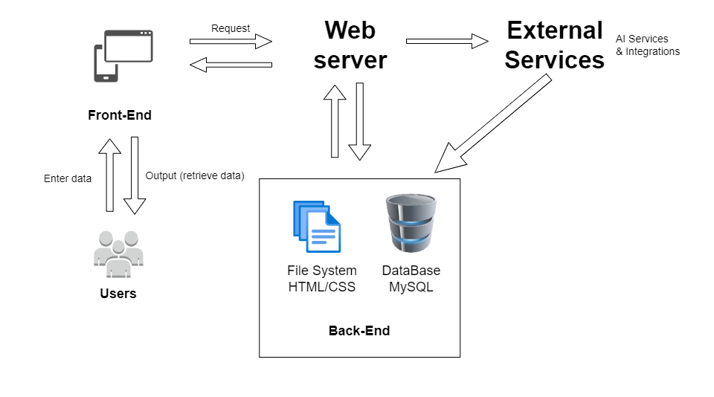

**Figure 3.1** System Architecture Diagram

## Entity Relationship Diagram

An ERD (Entity Relationship Diagram) shows the relationship between different roles and attributes within a system or database. We have 5 roles in our project Admin who can enroll or register users. It has one to many relationships. Supervisors has one to many relationships with students. They can schedule meetings, give feedback and discuss with students on virtual collaborative environment (group chat). FYP Coordinators can upload templates, schedule presentations. Student has many to one relationship with supervisor. They can view their progress. Additionally, Evaluator can give feedback and evaluate projects.

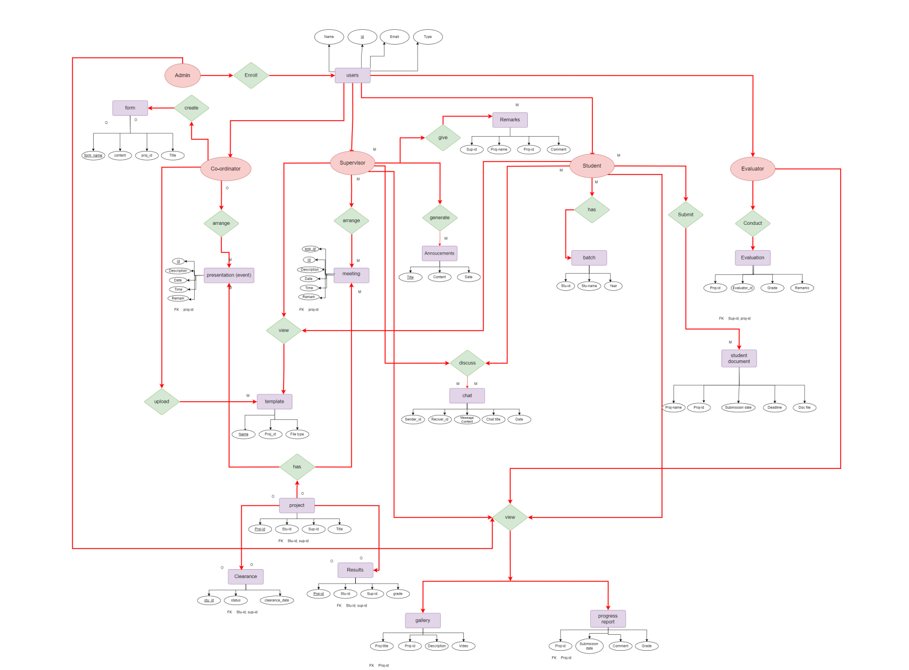

**Figure 3.2** Entity Relation Diagram

## Project Flow Diagram

The project flow diagram for the FYP Progress Recorder offers a structured overview of user activities, commencing from registration and progressing through project submission and subsequent stages. It visually represents the sequential flow of actions and interactions users undertake while navigating through the platform's functionalities. Acting as a guiding roadmap, this diagram aids users and developers in understanding the platform's usage and maintenance processes. By illustrating the sequence of activities, it provides clarity on the platform's operational structure and highlights significant touchpoints in the user journey. From initial engagement to post-submission interactions, the project flow diagram encapsulates the dynamic nature of user engagement within the FYP Progress Recorder, fostering coherence and comprehension in its operational framework.

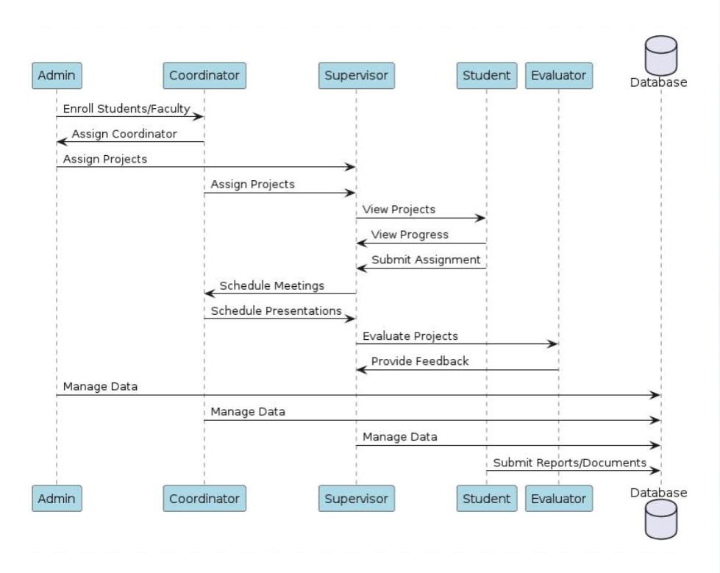

**Figure 3.3** Project Flow Diagram

## Use Cases

A use case diagram shows the interaction between users (actors) and this automated system to achieve specific goals or task it illustrates the features and functionalities that a system provides from the perspective of its users.

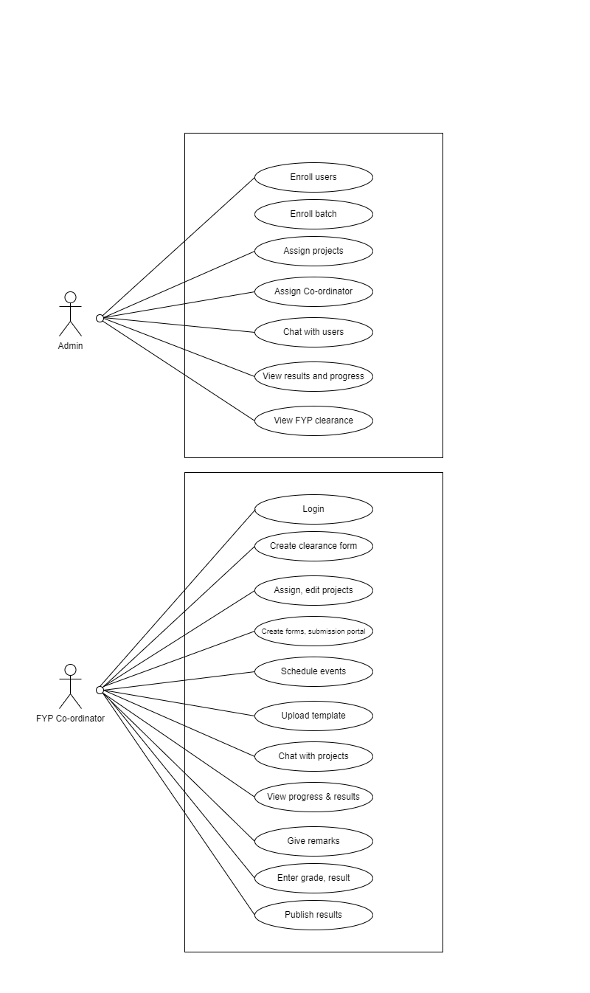

**Figure 3.4** Admin & Co-ordinator use case

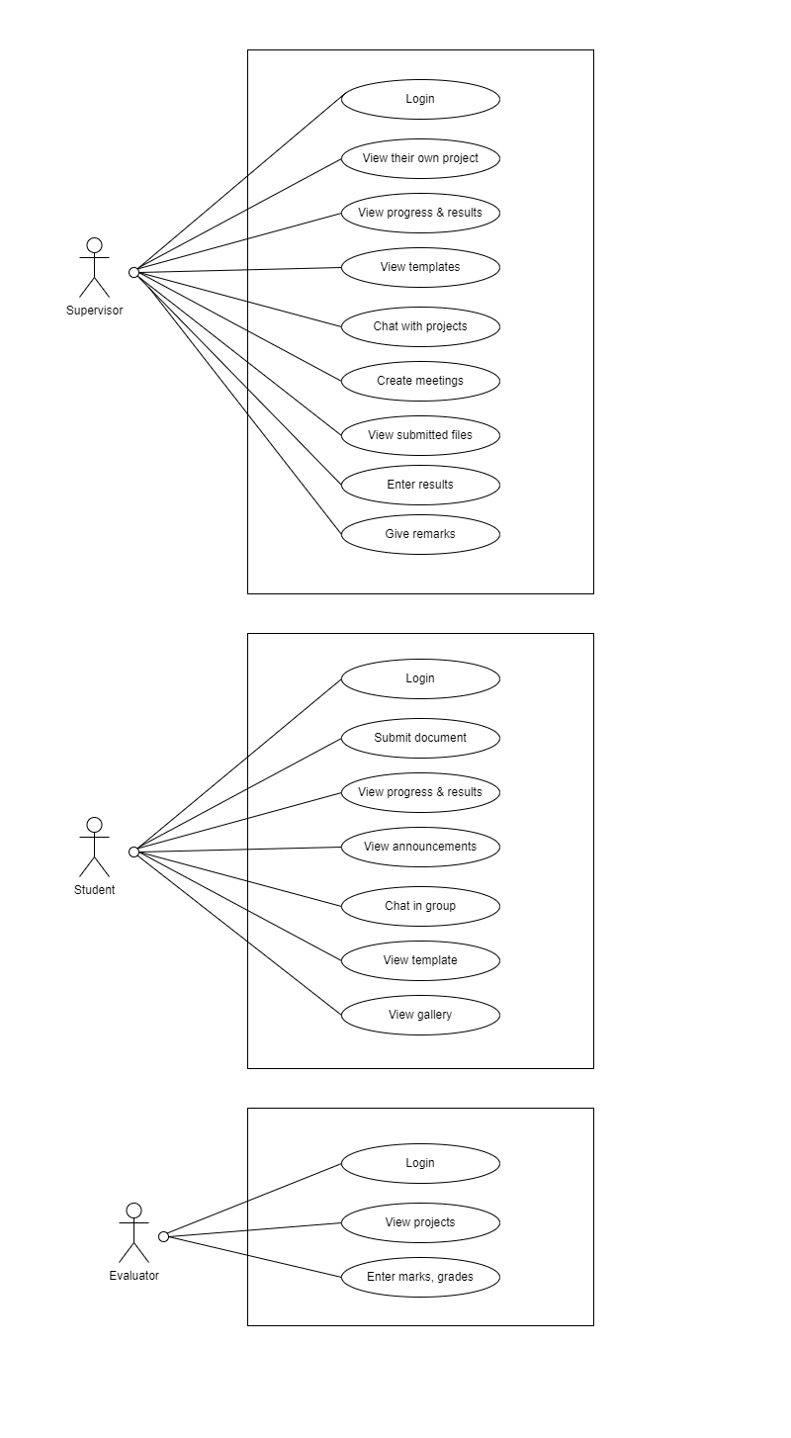

**Figure 3.**5 Supervisor, Student & Evaluator use case

## Activity Diagram

The activity diagram for the FYP Progress Recorder system visually represents the sequential steps users take to accomplish tasks, providing insights into user interactions with the system. It illustrates key actions such as document submission, feedback reception, and notification management. This diagram is essential for understanding the system's functionality and integration, guiding users through a cohesive experience and ensuring alignment with intended outcomes.

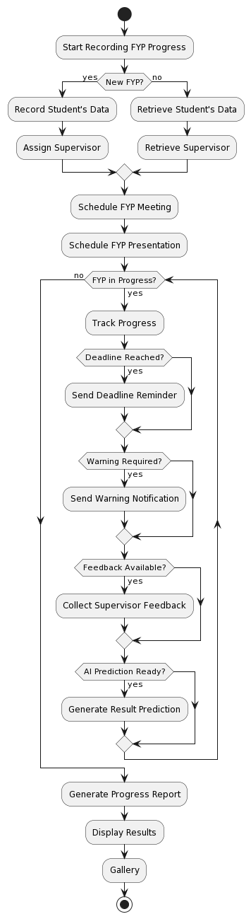

**Figure 3.6** Activity Diagram



## User Interface Design

This is the FYP Coordinator dashboard where coordinator can perform their activities.

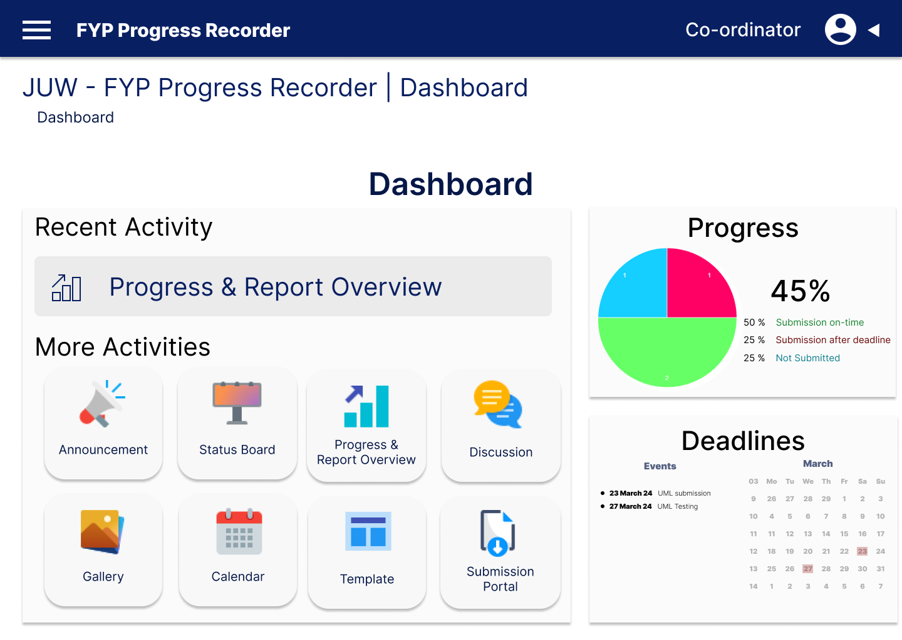

**Figure 3.7** Project Coordinator Dashboard Screen

Coordinator upload templates for students

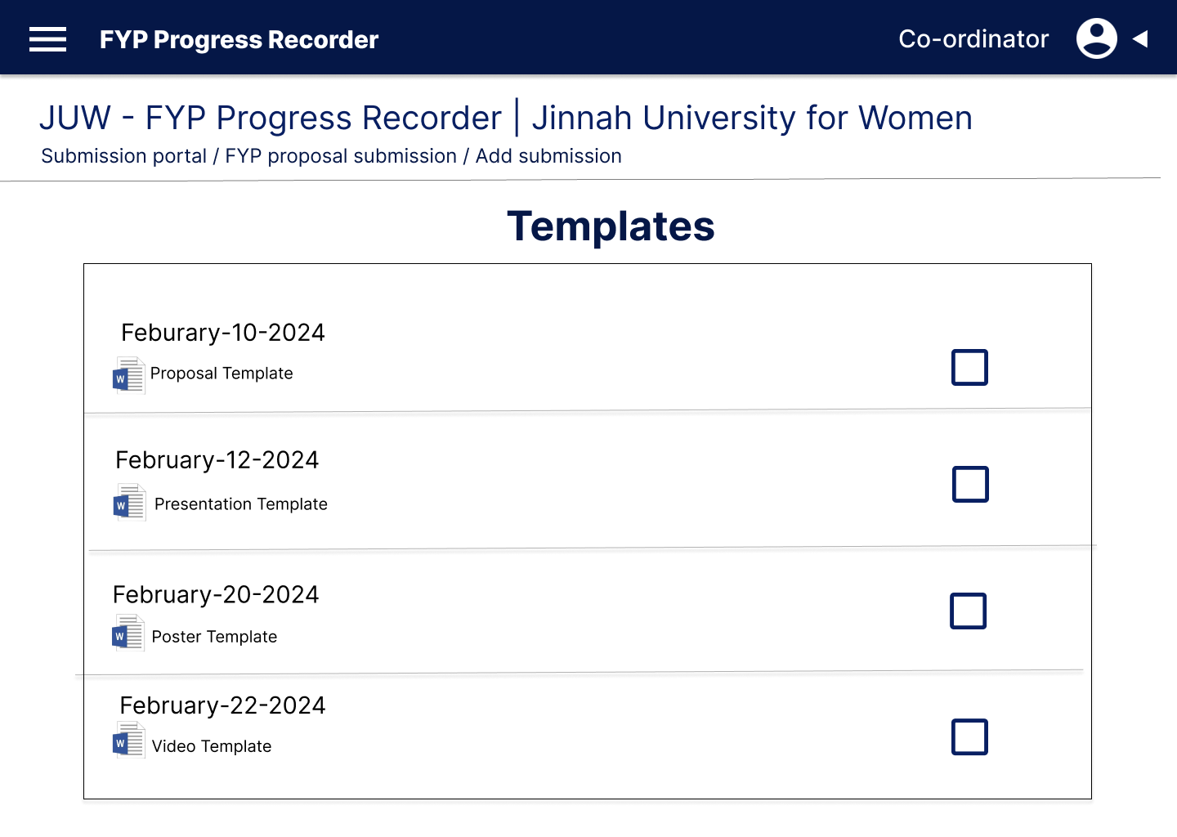

**Figure 3.8** Project Coordinator Activity Screen

Coordinator can view the students submitted videos here.

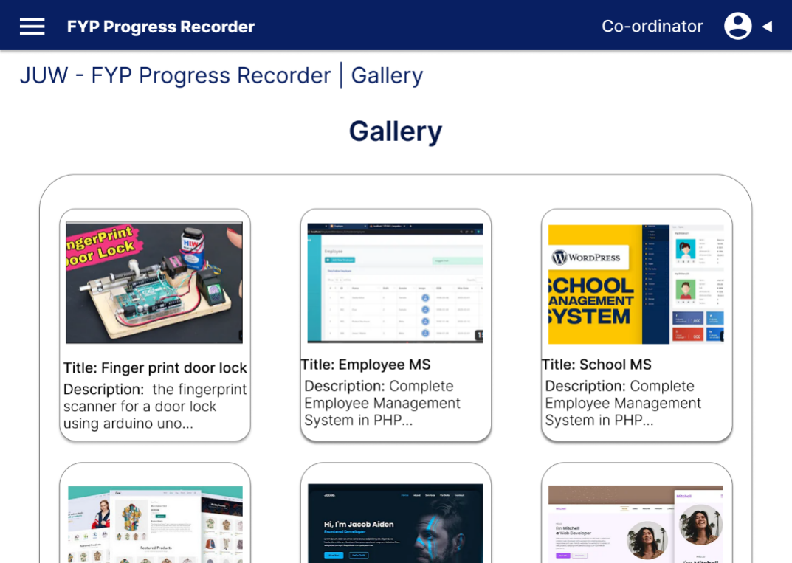

**Figure 3.9** Project Coordinator Gallery Screen

This is the FYP Supervisors Dashboard

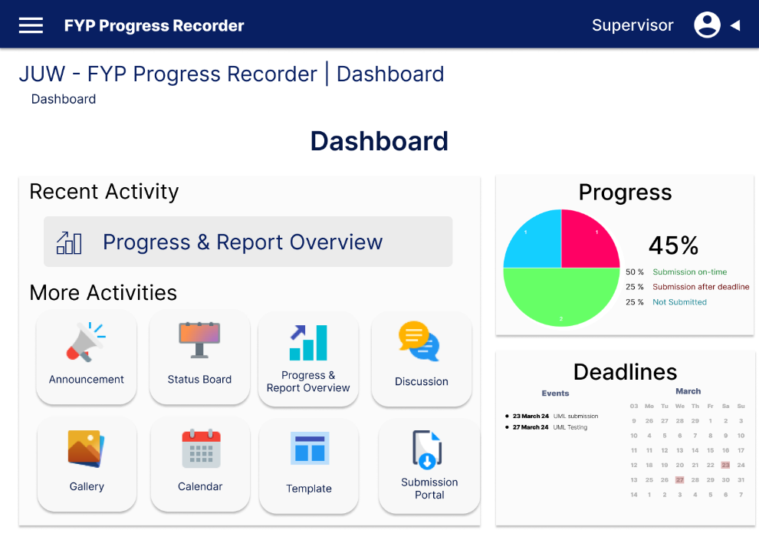

**Figure 3.10** Supervisor Dashboard Screen

Supervisors create submission portals for students to submit their reports.

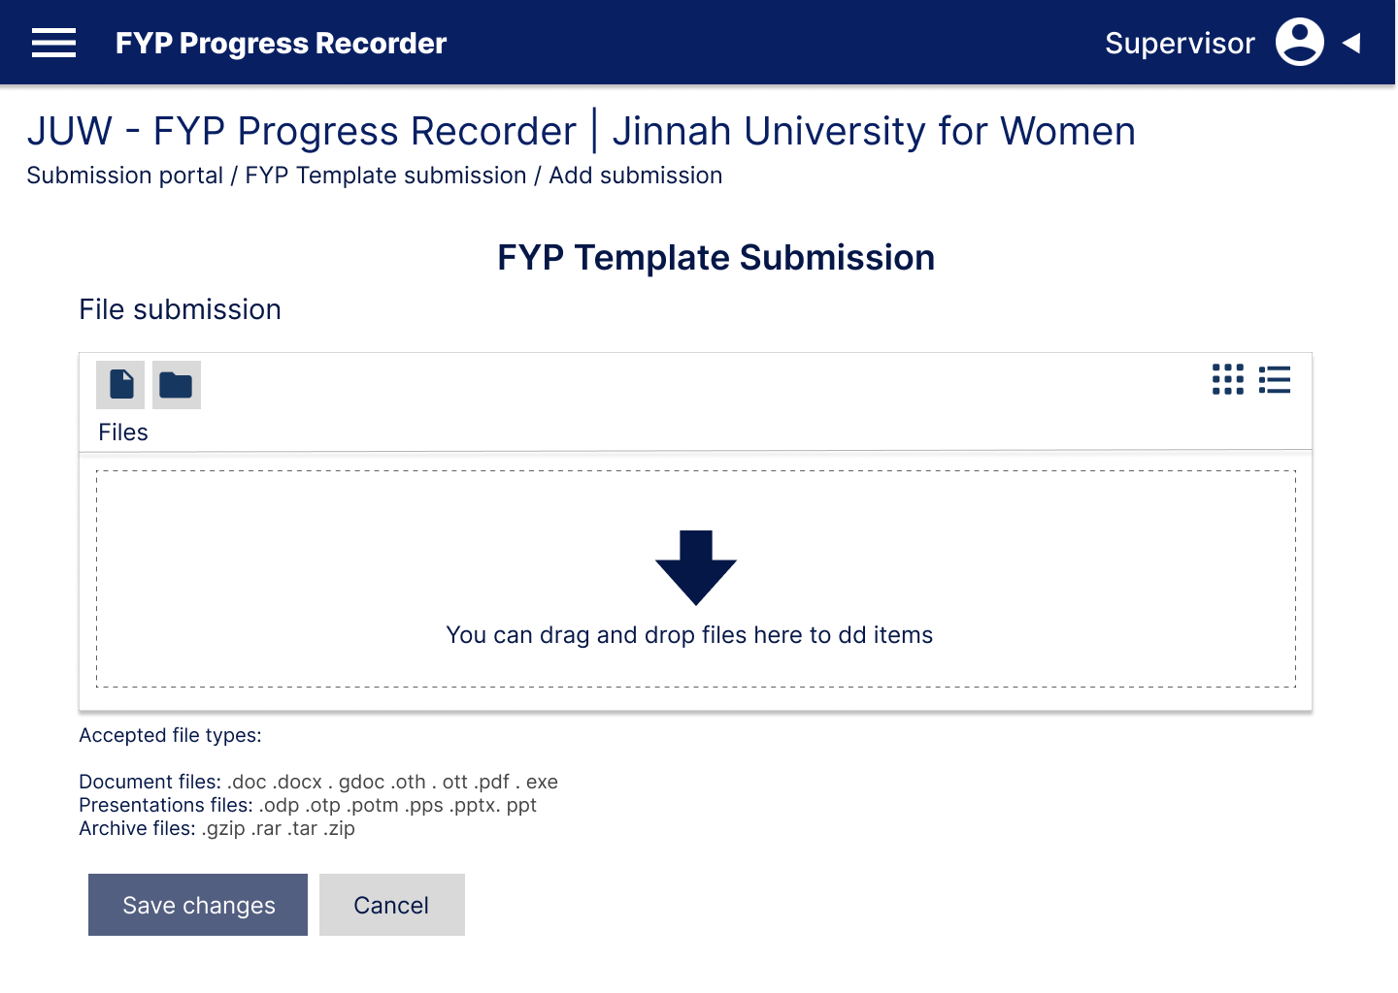

**Figure 3.11** Supervisor Activity Screen

Supervisors can schedule FYP meetings

.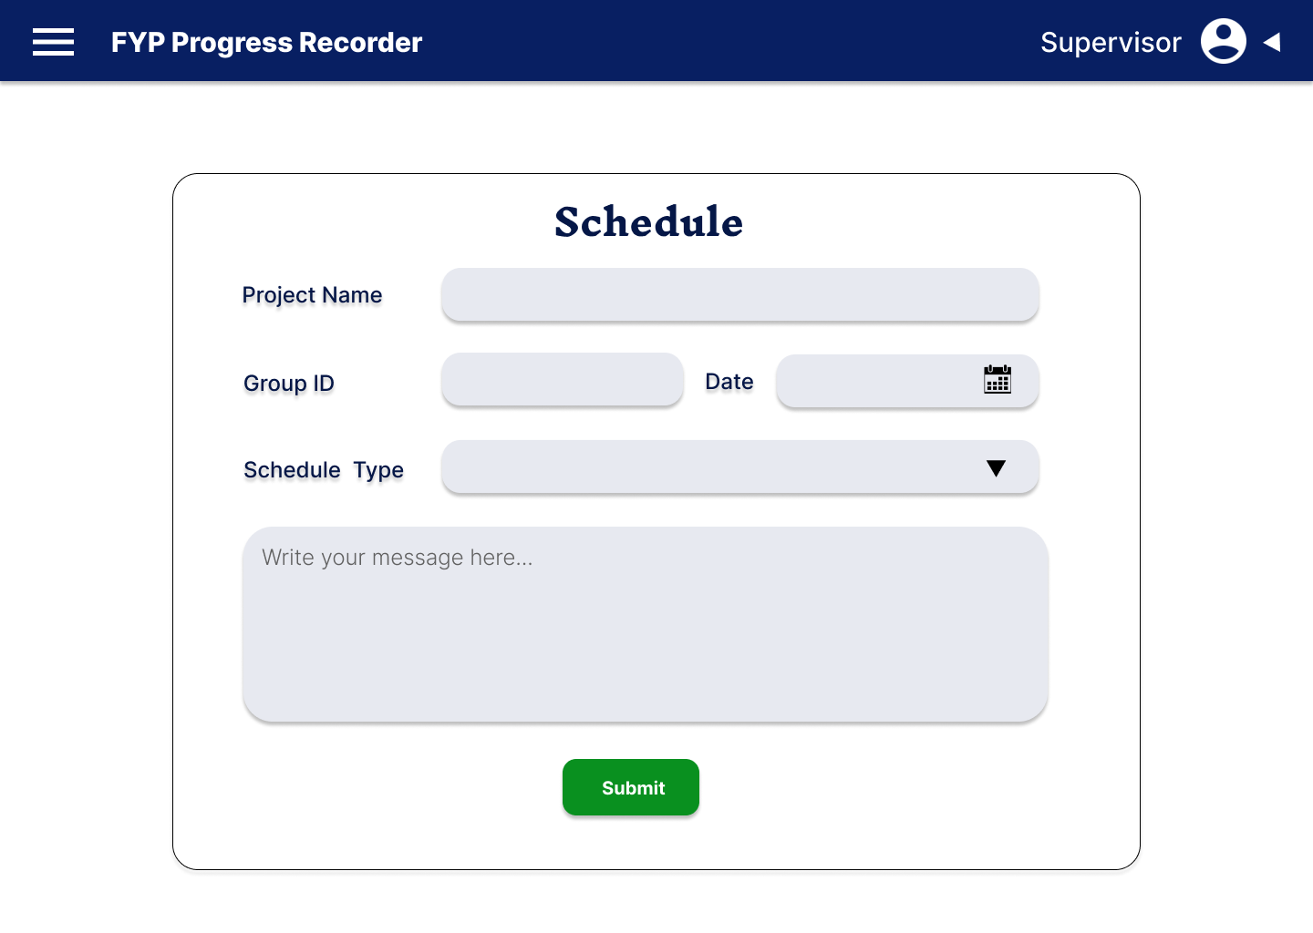

**Figure 3.12** Supervisor Meeting Screen

This is Students dashboard

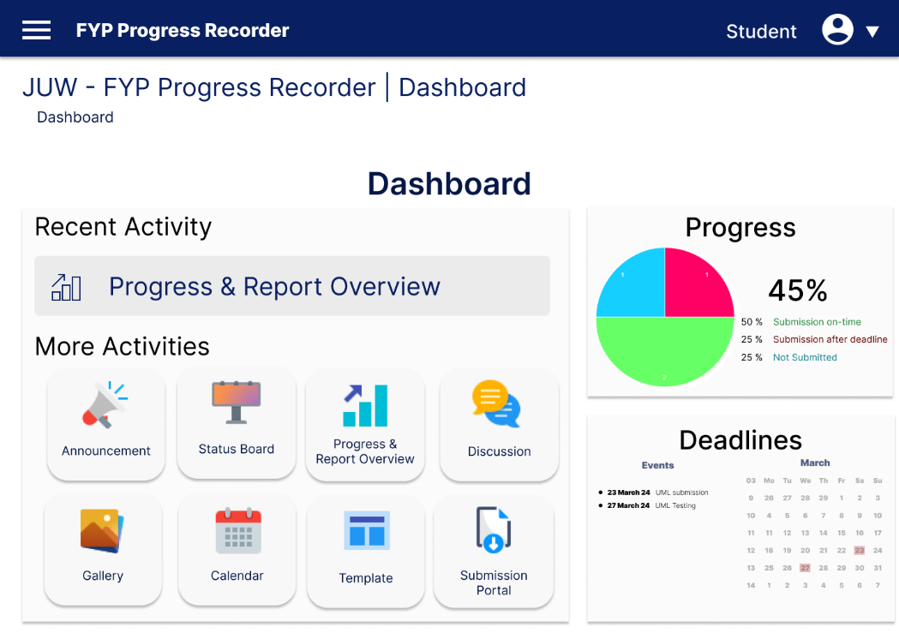

**Figure 3.13** Student Dashboard Screen

Students can upload their project video.

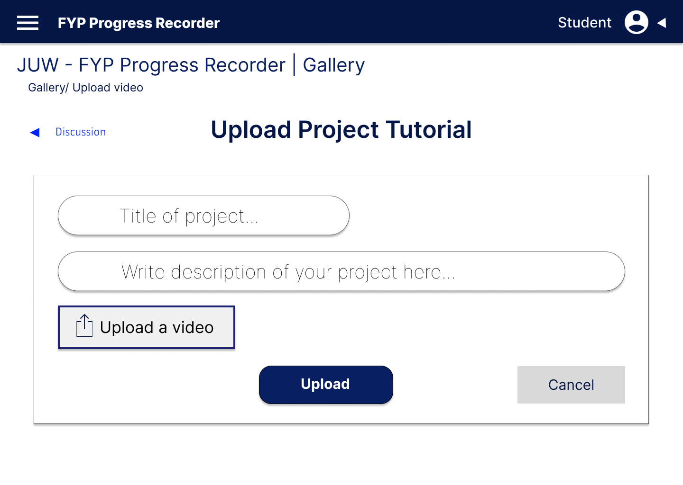

**Figure 3.14** Student Gallery Screen

Students can chat/discuss their queries regarding FYP to supervisors

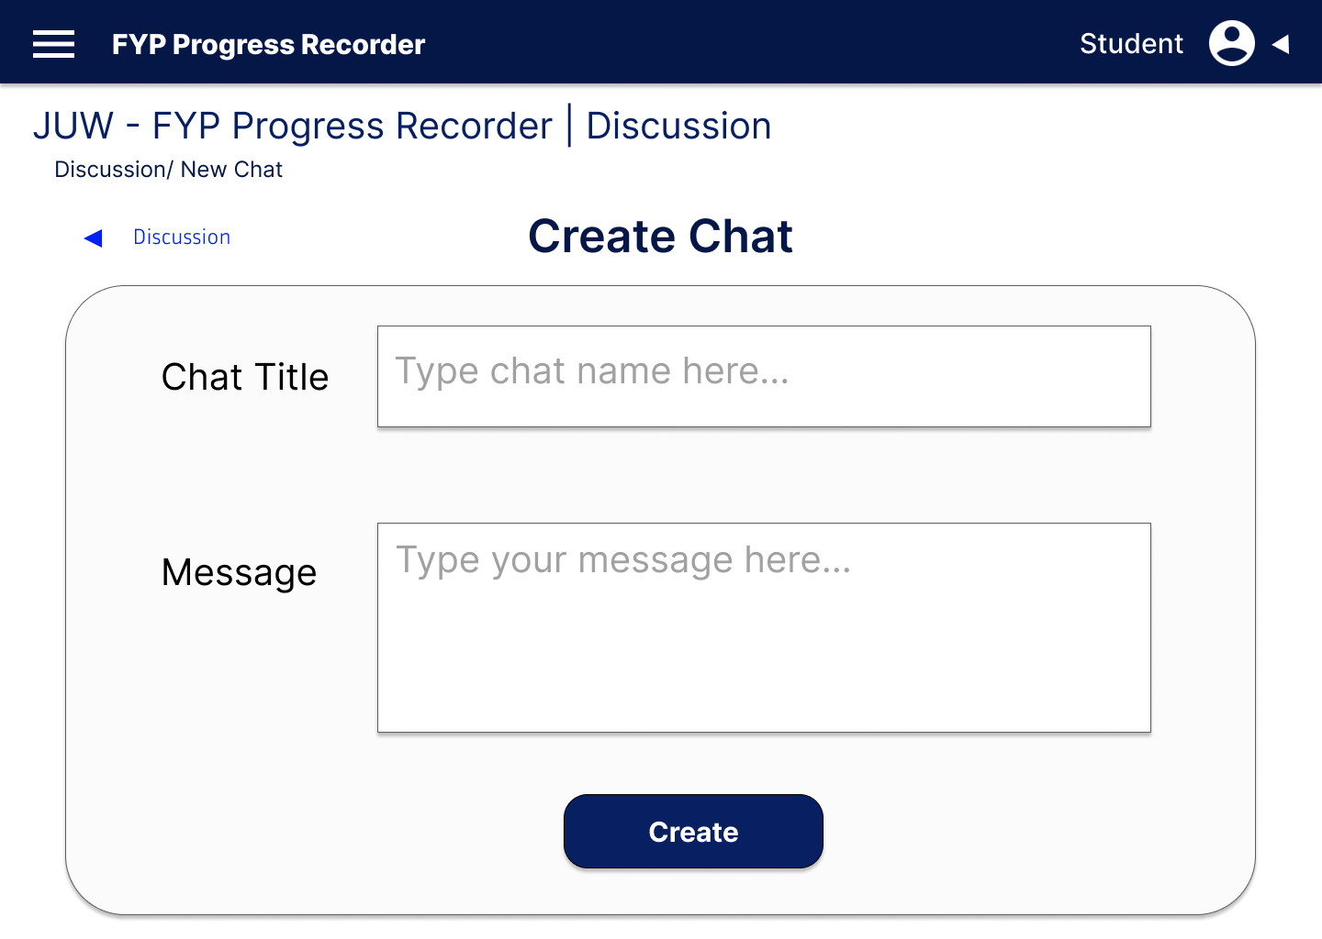

**Figure 3.15** Student Discussion Screen

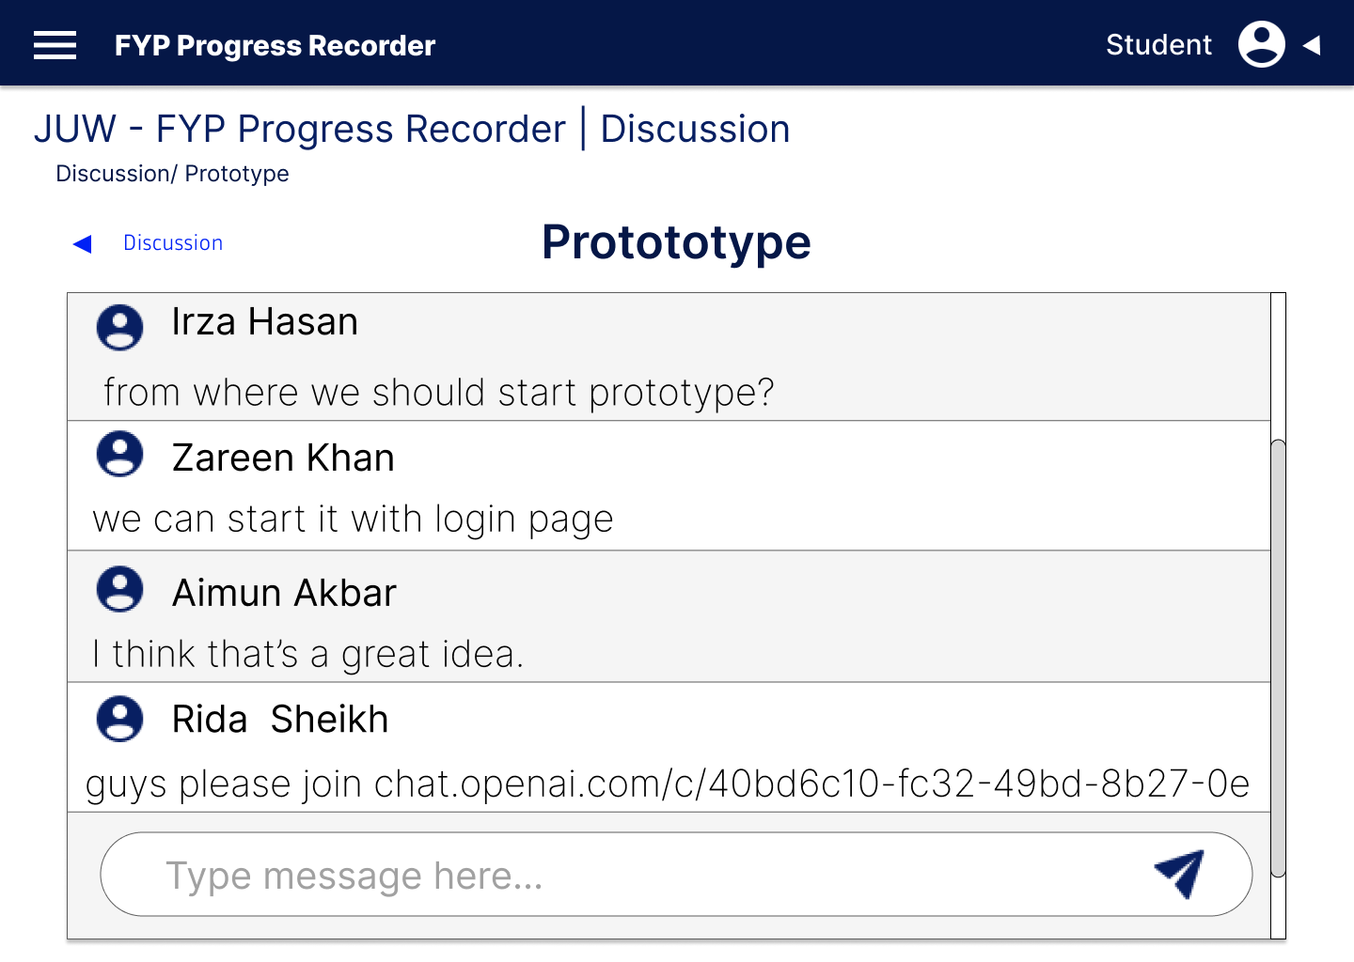

**Figure 3.16** Discussion Screen

Students can download their provided templates

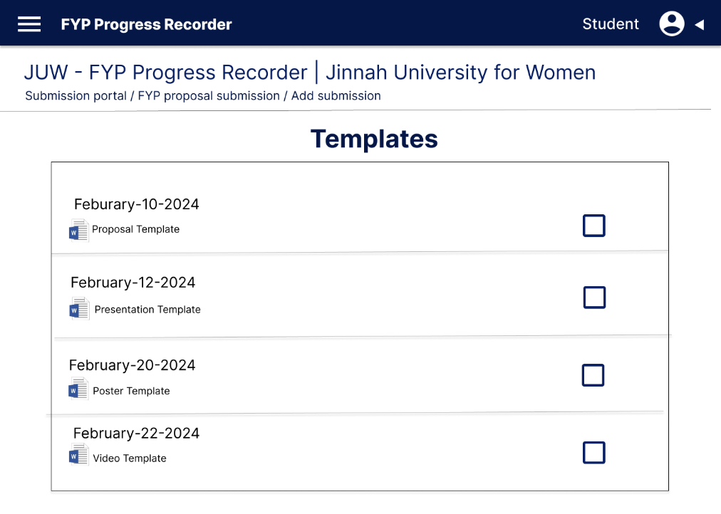

**Figure 3.17** Student Activity Screen

# CHAPTER 4

# PROJECT PLAN

A project plan defines project goals and objectives, specifies tasks and how goals will be achieved and identify what resources will be needed and associated budgets and timelines for completion. A project plan defines all work in a project and identifies who will do it.

## Process Model (Agile)

The FYP Progress Recorder project adopts an Agile methodology for its dynamic and iterative approach to software development. Agile principles emphasize the flexibility, collaboration, and responsiveness to change, allowing the project team to deliver incremental value to stakeholders. By breaking down the project into small, manageable iterations called sprints, Agile enables continuous feedback and adaptation, ensuring that the final product meets evolving requirements and customer needs.

### User Stories

A user story is concise, informal description of a feature or functionality from end-users perspective. It captures the “who”, “what”, and “why” of a requirement in a simple and understandable format. In FYP Progress RecorderSystem, there arefive usersareinvolved.Eachusersrequiredifferentfunctionalityaccordingto theirneed.Table4.1shows user stories.

**Table 4.1** User Stories

|  |  |  |  |
| --- | --- | --- | --- |
| **No.** | **As a** | **I want to …** | **So that …** |
| 1 | Admin | He/She wants to login into “FYP Progress Recorder” by using email and passwords | So that he/she can access the system’s features |
| 2 | Admin | He/She wants to assign roles | So that user can access only assigned features |
| 3 | Admin | He/She wants to view progress | So that he/she can get to know the overall progress |
| 6 | Co-ordinator | He/She wants to schedule and manage FYP presentations, | So that student can give presentations |
| 7 | Co-ordinator | He/She wants to upload templates | So that student can use them for their ease |
| 8 | Co-ordinator | He/She wants to assign projects | So that student can start work on it |
| 9 | Co-ordinator | He/She wants to create assignments | So that student can do assignments |
| 11 | Supervisor | He/She wants to provide feedback | So that student can get help from it |
| 12 | Supervisor | He/She wants to schedule meetings | So that we can discuss project status |
| 13 | Supervisor | He/She wants to generate notification | So that student can get reminder |
| 14 | Supervisor | He/She wants to discuss on chat | So that student can ask for difficulties |
| 16 | Student | I want to receive timely notifications | So that I can submit my document on time |
| 17 | Student | I want to use per-designed templates | So that I can follow define pattern of documents |
| 18 | Student | I want to submit documents | So that supervisor can get to know about progress |
| 19 | Student | I want to track my project progress | So that I can see if improvement needed or not |
| 21 | Evaluator | He/She want to view progress | So that he/she can give them remarks |
| 22 | Evaluator | He/She want to enter evaluation result | So that student can get to know their grade |

### Sprints Planning

Sprint planning sets the path for the FYP Progress Recorder project's development journey, breaking down tasks, timelines, and team roles. As shown in Table 4.2 Sprints Planning, careful scheduling ensures smooth progress, with each sprint outlining clear goals and achievements. This organized method encourages teamwork, responsibility, and steady progress towards project milestones.

**Table 4.2** Sprint Planning

|  |  |  |  |  |  |  |  |  |  |  |  |
| --- | --- | --- | --- | --- | --- | --- | --- | --- | --- | --- | --- |
| Project Name  Name | Project Manager  tManager | | | | StarStart Date  Date | | | End Date  Date | | Overall Progress  allProgress | |
| FYP Progress Recorder | Soomaiya Hamid | | | | January 01-2024 | | | December 31-2024 | | Prototypes, UML diagrams, Screen Layouts are completed, now accelerating with the development tasks. | |
| ProjectDeliverables | | Web application and mobile application. | | | | | | | | | |
| ScopeStatement | | This project aims to serve as a valuable system for efficiently and quickly managing and documenting the final year project process within the CSSE department in Jinnah University for Women. | | | | | | | | | |
| TaskName | | | StartDate | EndDate | | Team | Sizing | | AcceptanceCriteria /Definitionof  Done | | Priority |

|  |  |  |  |  |  |  |
| --- | --- | --- | --- | --- | --- | --- |
| Sprint 1- Initial Development | | | | | |  |
| Implement Admin panel | March 20-2024 | April 30-2024 | Development team | Small | Implement an admin panel that admin can register users, assign roles and assign projects | High |
| Database setup | March 20-2024 | April 30-2024 | Development team | Small | Setup database schema for storing students, supervisors, coordinators, evaluators and projects data | High |
| Develop core features | April 30-2024 | May 30-2024 | Development team | Large | Developing core features like: record-keeping, progress tracking and presentations/meetings schedules | High |
| Sprint 2–Iterative Development | | | | | |  |
| Implementing notifications and deadline feature | June 01-2024 | June 15-2024 | Development Team | Medium | Students can receive notifications from their supervisors and coordinators and they can receive warning after the deadline | High |
| Implementation of virtual collaborative environment feature | June 16-2024 | July 20-2024 | Development Team | Medium | Collaborative environment for easily discussion between students and supervisors | High |
| Implementing status board | July 21-2024 | August 10-2024 | Development Team | Medium | Status board for students to track their progress | High |
| Implementation of supervisor/evaluators feedback | August 11-2024 | August 25-20204 | Development Team | Large | Supervisors can give their feedback easily on every meeting and evaluators on evaluation time | High |
| Integration of AI result prediction feature | August 25-2024 | Sept 30-2024 | Development Team | Large | AI will predict the results on the basis of project progress | High |
| Sprint 3–Testing and Deployment | | | | | |  |
| Conduct thorough testing | October 01-2024 | 0ctober 20-2-24 | Scrum master/ Testing  team | Medium | Test the feature to identify bugs | High |
| Prepare Deployment Environment | October 21-2024 | Nov 15 -2024 | All Teams | Large | All feature tested, bug fixed, prepare environment for deployment | High |
| FYP Progress Recorder deployed | Nov16-2025 | Nov 30-2024 | All Teams | Large | FYP Progress recorder system officially deployed | High |
| Monitor system’s performance | Dec 01-2024 | Dec 15-2024 | PM | Medium | Monitor performance for users satisfaction | High |
| Project success review | Dec 16-2024 | Dec 31-2024 | All team | High | It is based on its adaptation, feedback and satisfaction | High |

### Sprints Sizing

Sprint sizing, as shown in Table 4.1.3 Sprints Sizing, is like dividing tasks into manageable chunks for our project plan. Each chunk gets a certain number of story points, which helps us balance our workload and meet deadlines. By doing this, we can stay flexible and adjust to changes easily. It's like breaking a big task into smaller pieces, making it easier to handle. This way, we can work efficiently and stay on track to finish our project on time. It's all about staying organized and focused on reaching our goals.

**Table 4.3** Sprint Sizing

|  |  |  |  |  |  |  |  |
| --- | --- | --- | --- | --- | --- | --- | --- |
| SprintName | SprintDuration | No. ofStoriesplanned | No. ofStoriesdelivered | % ofStoriescompleted | No. ofStorypointsplanned | No. ofStorypointsdelivered | % of Storypointscompleted |
| Initial Development | March 20-2024 to May 30-2024 | 3 | 3 | 100% | 3 | 3 | 100% |
| Iterative Development | June 01-2024 to Sept 30-2024 | 5 | 4 | 59% | 5 | 3 | 70% |
| Testing and Deployment | October 01-2024 to Dec 31-2024 | 5 | 4 | 79% | 5 | 5 | 100% |

## Timeline with Milestones

The project timeline and milestones outline a comprehensive 12-month plan, specifying objectives and deliverables for each sprint. This structured roadmap, depicted in Table 4.2, enables us to adhere to development goals while allowing room for necessary adjustments during the project life-cycle. Each milestone signifies a pivotal advancement towards achieving our vision for the FYP Progress Recorder platform. This approach ensures strategic progress and adaptability in realizing our project goals.

|  |  |  |
| --- | --- | --- |
| **Milestone** | **Tentative Date** | **Deliverable(s) completed** |
| Data Gathering and Project Proposal | 1 Month | Work Plan, Project Proposal |
| Prototype and Requirement Gathering | 2 Month | Prototype & SRS |
| Database & Data Entry | 3 Month | Database |
| Website front-end development | 4 Month | Website front-end and Database integration |
| Develop key features | 5 Month | Key features developed |
| AI Result Prediction Feature integration | 6 Month | AI feature integrated |
| Front-end for Mobile App | 7 Month | Developed Front-end |
| Back-end features for Mobile App | 8 Month | Developed Back-end |
| Integration Mobile App with Database | 9 Month | Integration Mobile App with Database |
| Testing | 10 Month | Complete Tested product |
| Mobile and Website integration | 11 Month | Mobile and Website integration |
| Deployment and prepare project report. | 12 Month | Deployment and prepare project report. |

**Table 4.4** Timeline with Milestone

# CHAPTER 5

# TEST PLAN

A test plan refers to a detailed document that registers the test strategy, objects, schedule, estimations, deadlines, and for completing that particular design. Suppose its design is to examine the tests demanded to ensure the product is in action duly - managed by test directors.

## Test Cases

### This section details the test cases employed to verify the functionality, usability, and performance of the FYP Progress Recorder system. Each test case encompasses distinct scenarios and user interactions, facilitating the detection and resolution of potential issues or bugs prior to deployment. These test cases are thoughtfully crafted to encompass all facets of the platform, ranging from fundamental functionalities to advanced features, thereby ensuring a smooth and dependable user experience.

### Enroll Faculty Test Case

**Table 5.1** Enroll Faculty Test Case

|  |  |  |  |  |
| --- | --- | --- | --- | --- |
| Test case 1 | Fields | Inputs | Actual results | Result |
| Admin enroll faculty members | Name | Soomaiya Hamid | Entries will be shown in faculty table | Successful |
| Designation | Lecturer | Successful |
| Position | Supervisor | Successful |
| Password | 123 | Successful |

### 5.1.2 Enroll Student Test Case

**Table 5.2** Enroll Student Test Case

|  |  |  |  |  |
| --- | --- | --- | --- | --- |
| Test case 1 | Fields | Inputs | Actual results | Result |
| Admin enroll students | Name | Rida Shaikh | Entries will be shown in student table | Successful |
| Enrollment no | 27067 | Successful |
| Year | 2021 | Successful |
| Batch | SE | Successful |

### 5.1.3 Schedule Presentation Test Case

**Table 5.3** Schedule Presentation Test Case

|  |  |  |  |  |
| --- | --- | --- | --- | --- |
| Test case 1 | Fields | Inputs | Actual results | Result |
| Supervisor schedule presentation | Project title | FYP Progress Recorder | Entries will be shown in presentation record table | Successful |
| Time | 10:45am | Successful |
| Date | 21/may/2024 | Successful |

## Automated Testing Tools

To optimize the testing process and enhance efficiency, the FYP Progress Recorder project utilizes automated testing tools. These tools automate repetitive tasks, including regression testing and performance testing, resulting in time and resource savings. By automating testing procedures, any issues or regressions introduced during development are promptly detected and remedied. Furthermore, automated testing tools offer extensive test coverage and produce comprehensive reports, facilitating the monitoring of testing progress and informed decision-making based on data. In summary, the adoption of automated testing tools contributes to elevating the quality and dependability of the FYP Progress Recorder system.

# 

# CHAPTER 6

# IMPLEMENTATION DETAILS

During the implementation phase of the FYP Progress Recorder project, the focus is on transforming design specifications and requirements into operational software components. This phase includes coding, testing, integration, and deployment to ensure the platform aligns with its intended objectives. The development team will collaborate to write code based on design specifications, following coding standards and best practices to uphold code quality and facilitate maintainability of the system. This concerted effort ensures that the FYP Progress Recorder system is developed effectively and in accordance with project requirements.

## Tools and Technology

For Documentation tool:

* For WebApp Github
* MS word, powerpoint

For Technologies:

* Front-End: Html, CSS, JavaScript
* Backend: Python, PHP
* For MobileApp: Flutter
* For Database: MySQL

## Data Dictionary

Data dictionary is a collection of names, definitions and attributes about data elements that are being used or captured in a database or system.

**Table 6.1** Data Dictionary

|  |  |  |  |
| --- | --- | --- | --- |
|  |  |  |  |
|  |  |  |  |
|  |  |  |  |
|  |  |  |  |
|  |  |  |  |
|  |  |  |  |
|  |  |  |  |
|  |  |  |  |

## Version Control

Git is a free, open-source, distributed interpretation control system that handles source law changes in software systems of all sizes. Git allows multiple inventors to work together on the same design with ease. On the other hand, GitHub is a company that offers a pall-grounded depository allowing inventors to store and manage their law and to track and control law changes.

Version 1 (uploaded by ).

Version 2 (uploaded by ).

Version 3 (uploaded by ).

Version 4 (uploaded by ).

## Web APIs / Web Services

Within the FYP Progress Recorder project, the utilization of Web API and services stands as an essential component, facilitating effective communication and interaction among various features. These API’s are designed to expose essential functionality and data to eternal systems, fostering seamless integration with third-party services. They empower advanced features like user-authentication and data management of FYP Progress Recorder. By focusing on the development of robust and well defined/ documented API’s the aim is to ensure interoperability, scalability and adaptability, thereby covering the way for future expansions and integration with the diverse systems.

## Website Development

The goal of the FYP Progress Recorder project is to create a user-friendly online platform. It will help users to manage data, schedule events, track their progress and access project resources. We will design the front-end, develop back-end and integrate database, and thoroughly test for reliability. The front-end will be visually intuitive, while the back-end will manage core functionalities and data. We will ensure that the platform works smoothly on different devices and browsers.

**Faculty:**

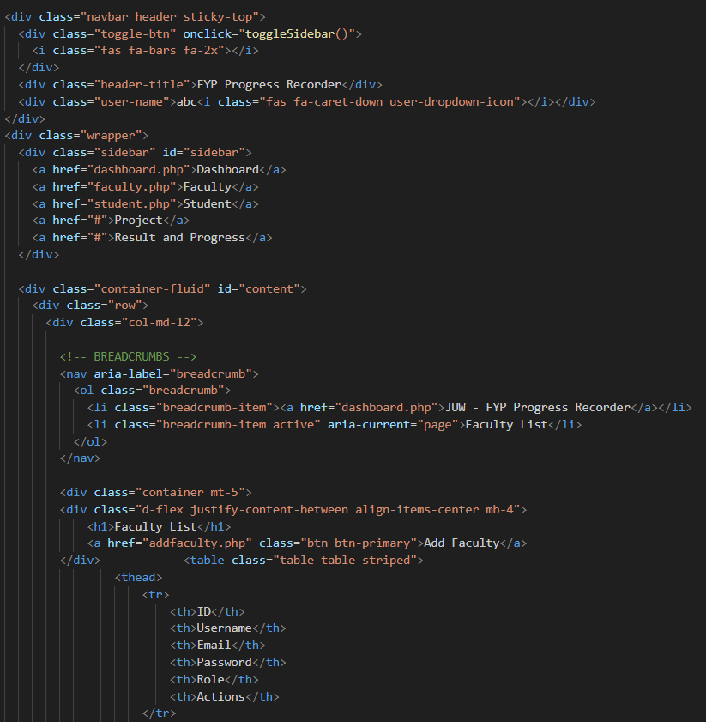

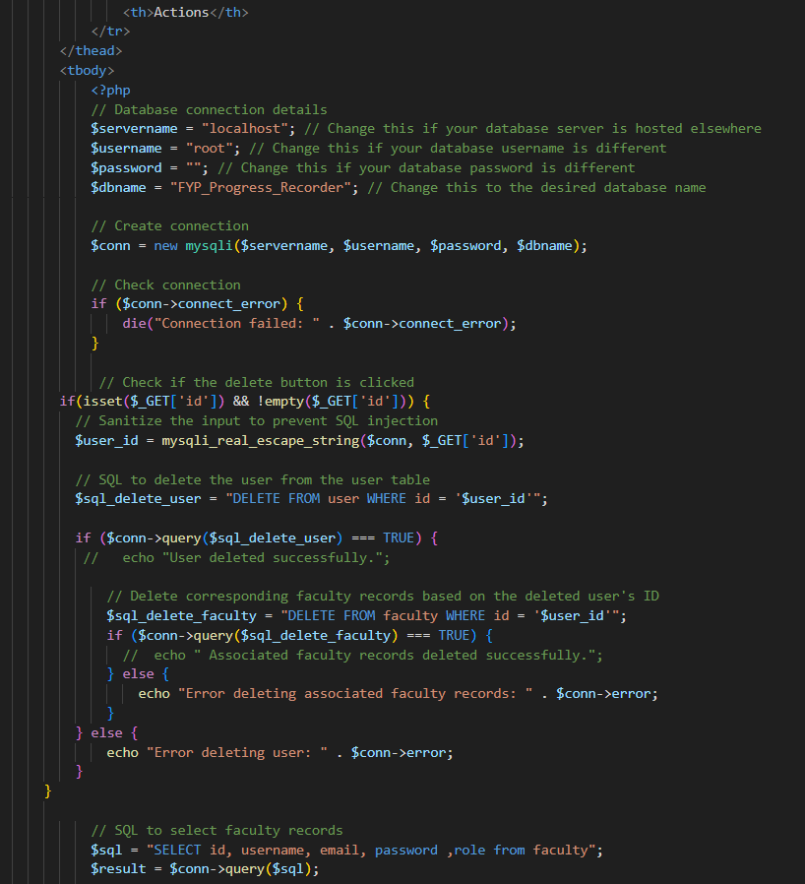

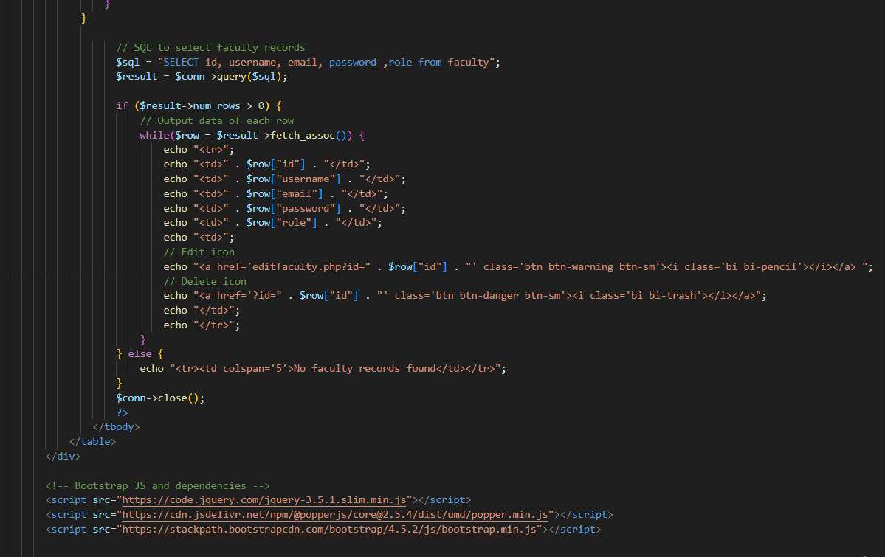

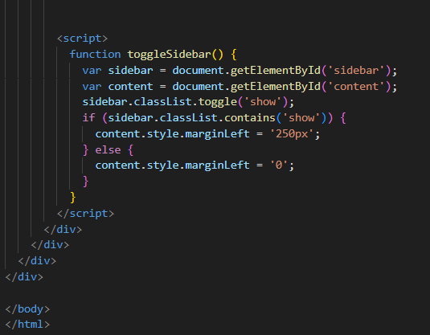

Add faculty:

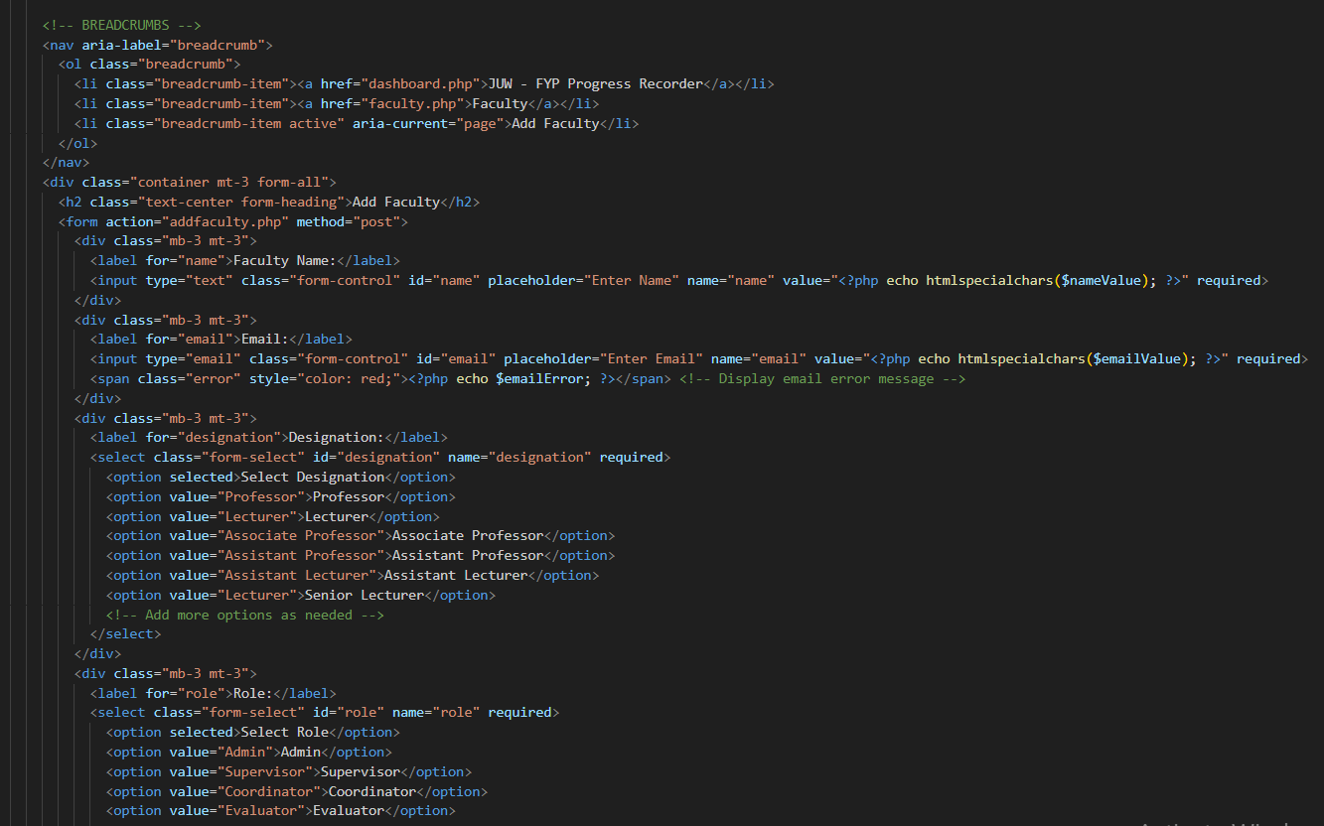

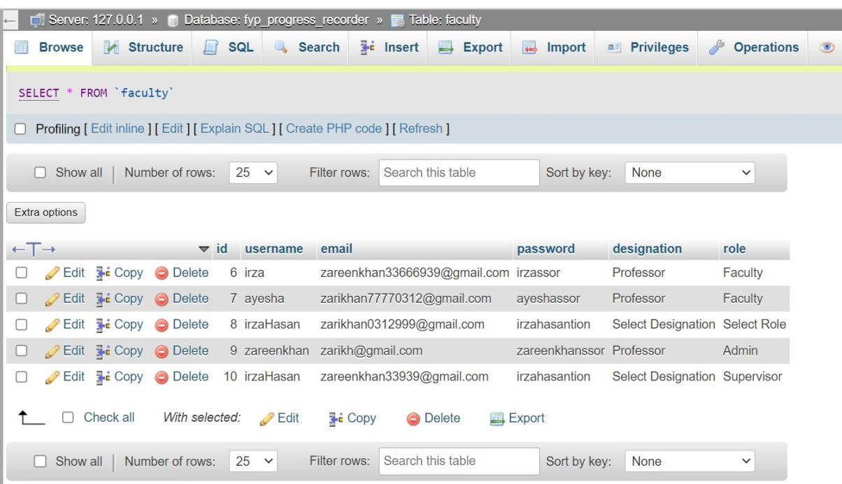

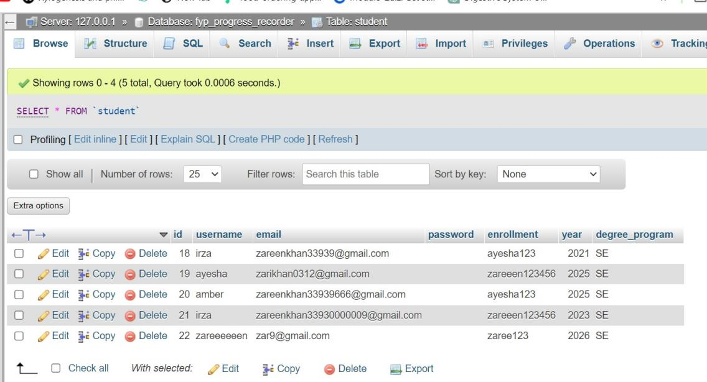

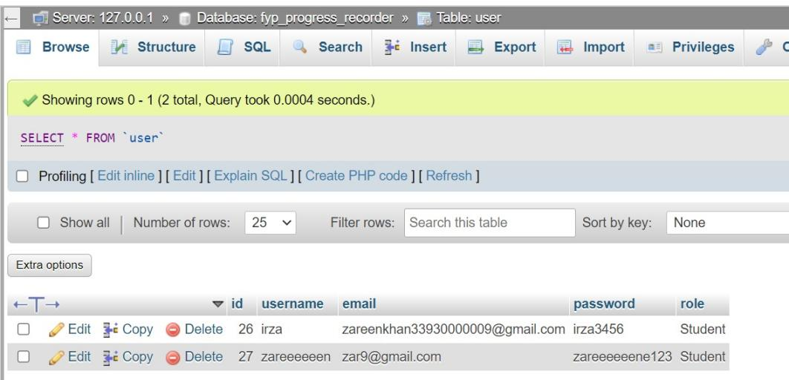

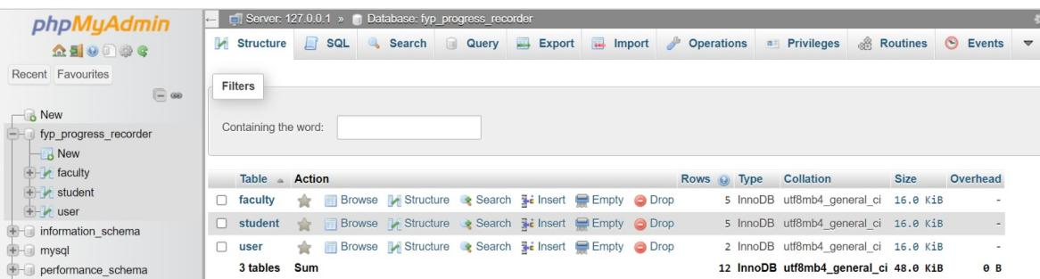

Dashboard:

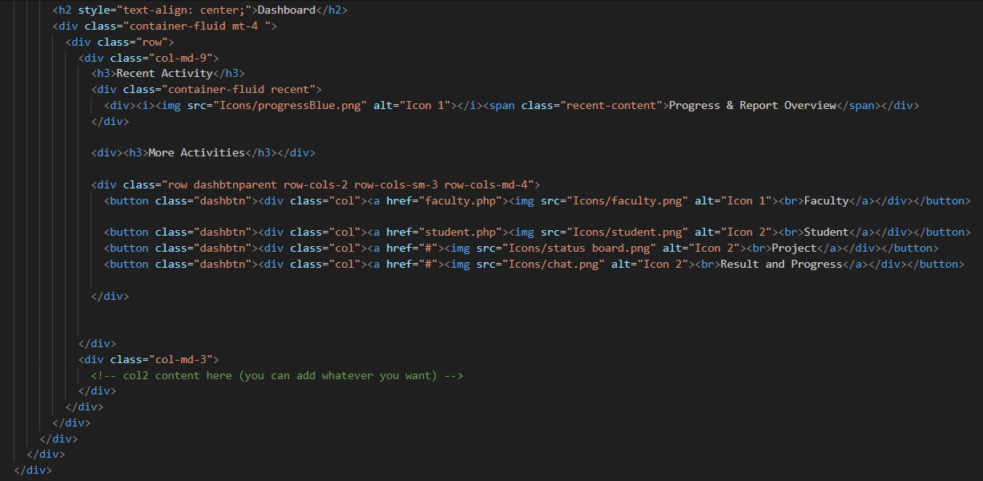

Student:

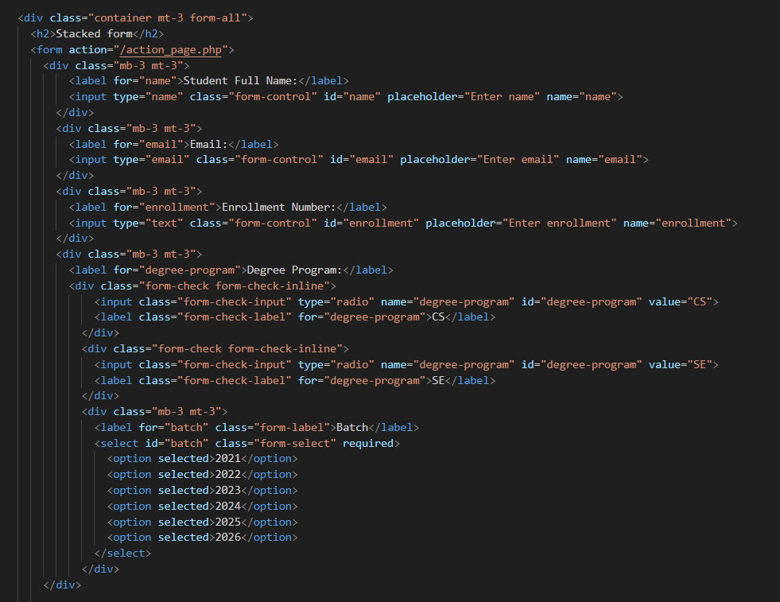

Add student:

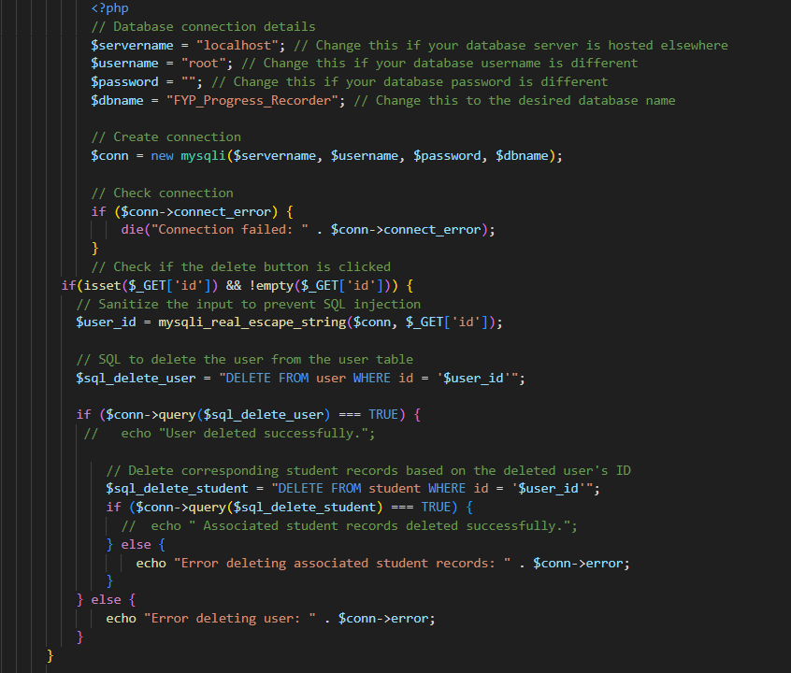

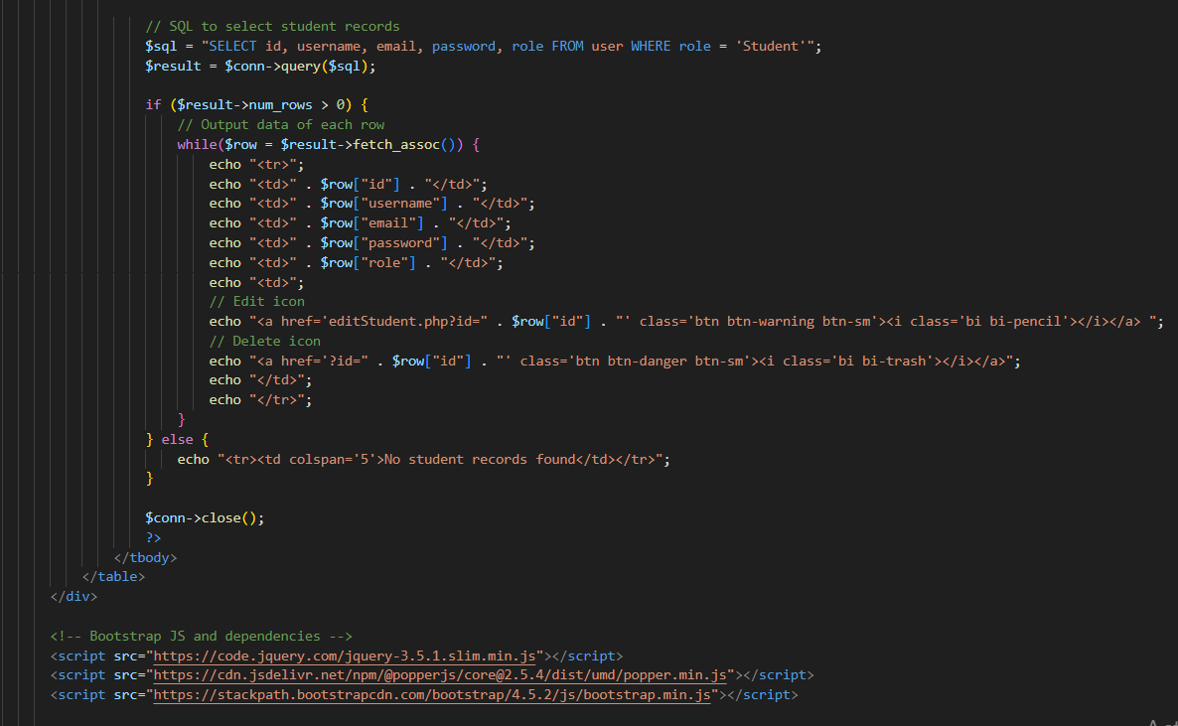

Student.php

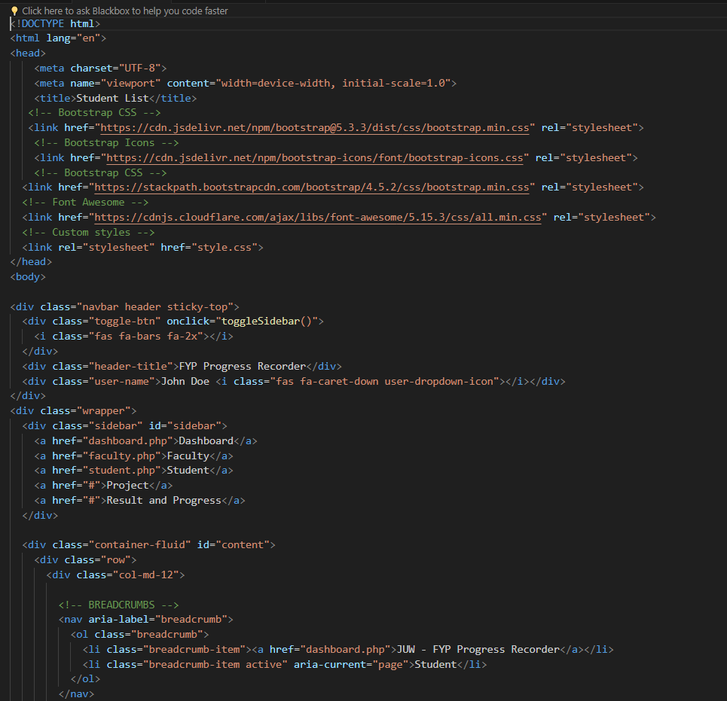

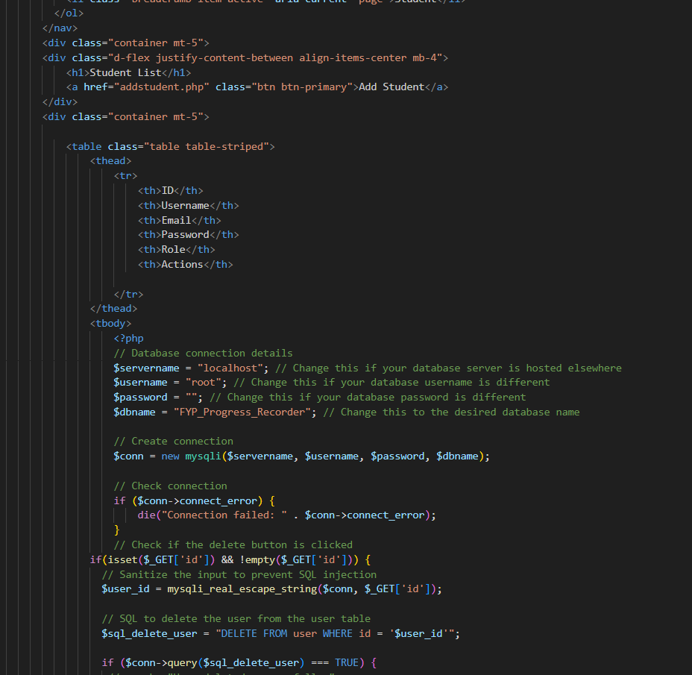

Schedule:

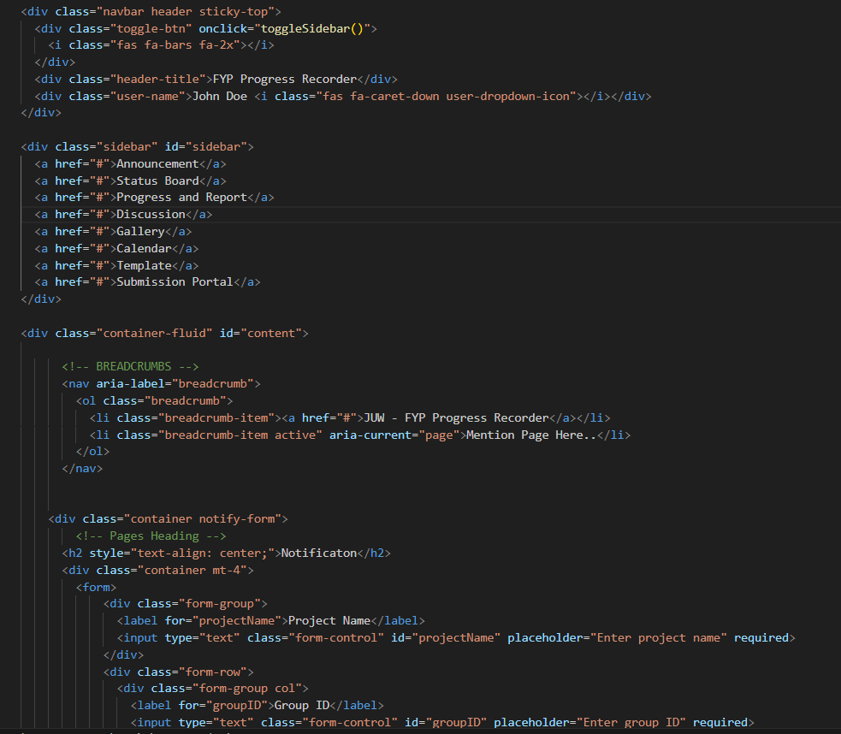

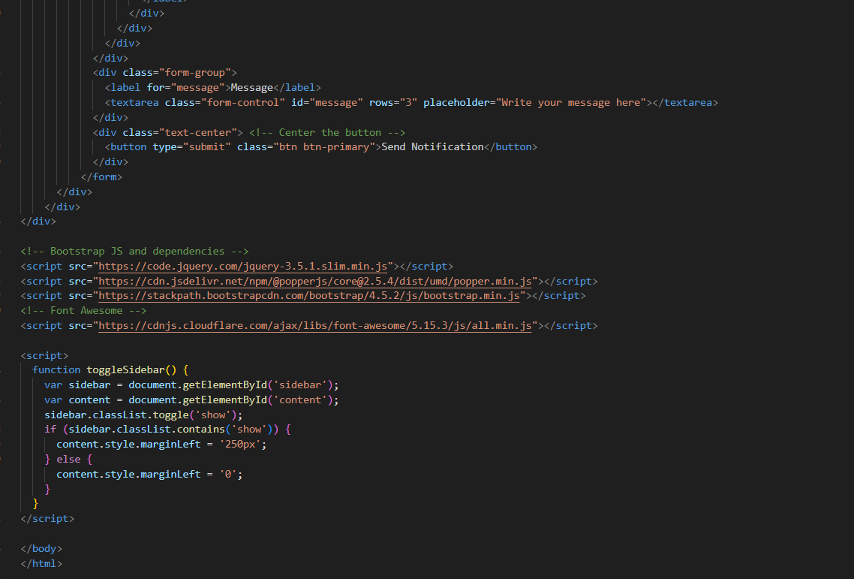

## Mobile Application Development

We're working on developing a mobile app for the FYP Progress Recorder project. It'll be available for both iOS and Android devices, offering users an easy way to track their progress on their phones and tablets. We're focusing on making the app user-friendly and smooth to use. This involves designing the look and feel, coding the front and back ends, connecting to web services, and testing it all thoroughly to make sure it works well on different devices. The app will match the website's style while using mobile features to make it even easier to use.

## Deployment During the deployment phase of the FYP Progress Recorder project, our main goal is to smoothly launch both the website and mobile app. We'll host the website on a dependable web hosting service to ensure it is easily accessible and runs smoothly. We'll keep an eye on its performance and make any necessary adjustments to keep it running well. Similarly, we'll upload the mobile app to app stores like Google Play Store and Apple App Store, following all guidelines carefully to ensure it is delivered seamlessly to users. We'll conduct thorough testing to make sure users can access and use the platform without any issues, giving them a reliable and enjoyable experience on both website and mobile.

## Website Hosting

To ensure accessibility and smooth performance, the FYP Progress Recorder website is hosted on a reliable web hosting service. This involves setting up servers, implementing code, and monitoring the system's health to ensure everything runs smoothly for users. We continuously monitor and optimize to maintain uptime and efficiently use resources. By maintaining a robust hosting infrastructure and regularly improving performance, the FYP Progress Recorder ensures users have a seamless and reliable experience when using the platform.

## Mobile Application Deployment

The FYP Progress Recorder mobile app is available for users to download from popular app stores like Google Play Store and Apple App Store. To get it there, we make sure the app is packaged correctly and follows all the store rules. We also manage updates to keep the app running smoothly. After it's launched, we keep a close watch on user feedback and how people are using the app. This helps us find any problems and make the app better for everyone. By paying attention to how the app is doing and listening to users, we can make sure it's always getting better and giving users the best experience possible.

# CHAPTER 7

# CONCLUSION AND FUTURE WORK

FYP Progress Recorder is an online portal that manages the Final Year projects (FYP). It aims to provide centralized automation to the whole FYP management process from registration to final results. It provides a paperless environment and helps to track students' participation. It not only keeps track of all the project stages but also monitors and evaluates the project's progress. Our project provides quick and easy access to FYP management by bridging the gap between the FYP coordinator, supervisor, evaluator and student. Process Automation of a system could be a popular platform in today's world. This system is designed with the functionality of exchange information between students, supervisors and project coordinator. Students can view the status of their submission, project progress, they can chat in group. The FYP coordinator will be granted full access of this system to manage project, schedule presentations and assign projects to students. System will be managed by admin. Admin will monitor system and keep track of data, maintain access level of users.

# REFERENCES

# Use IEEE format

# APPENDIX A

# SCREENSHOTS

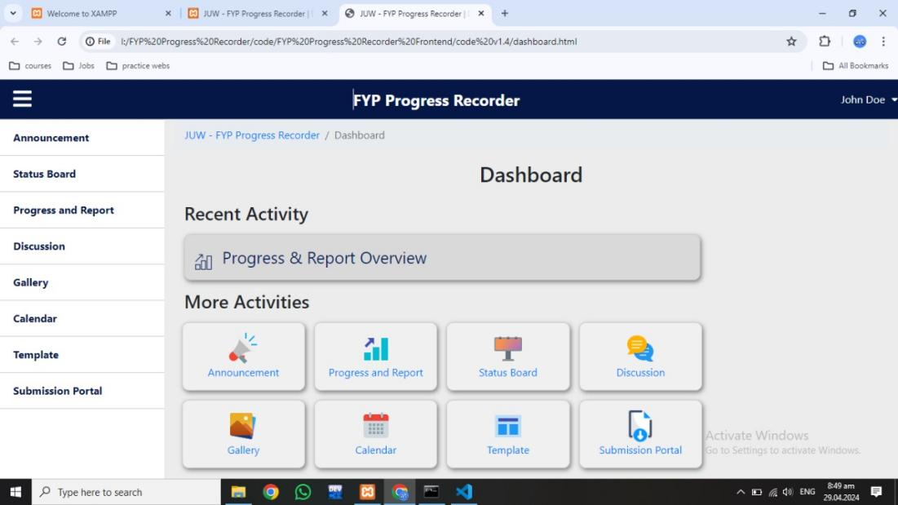

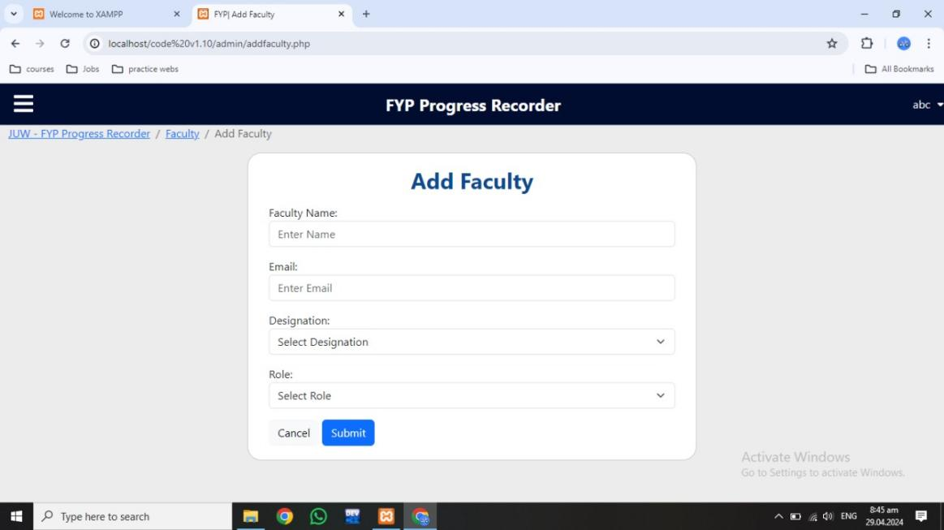

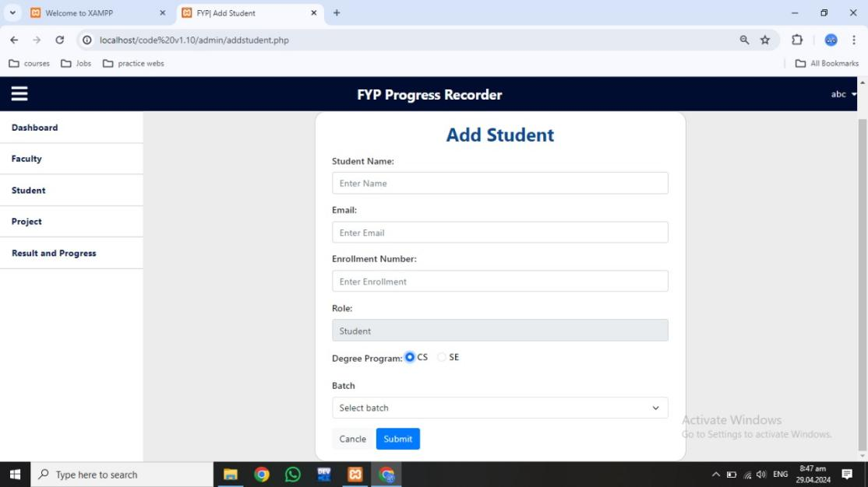

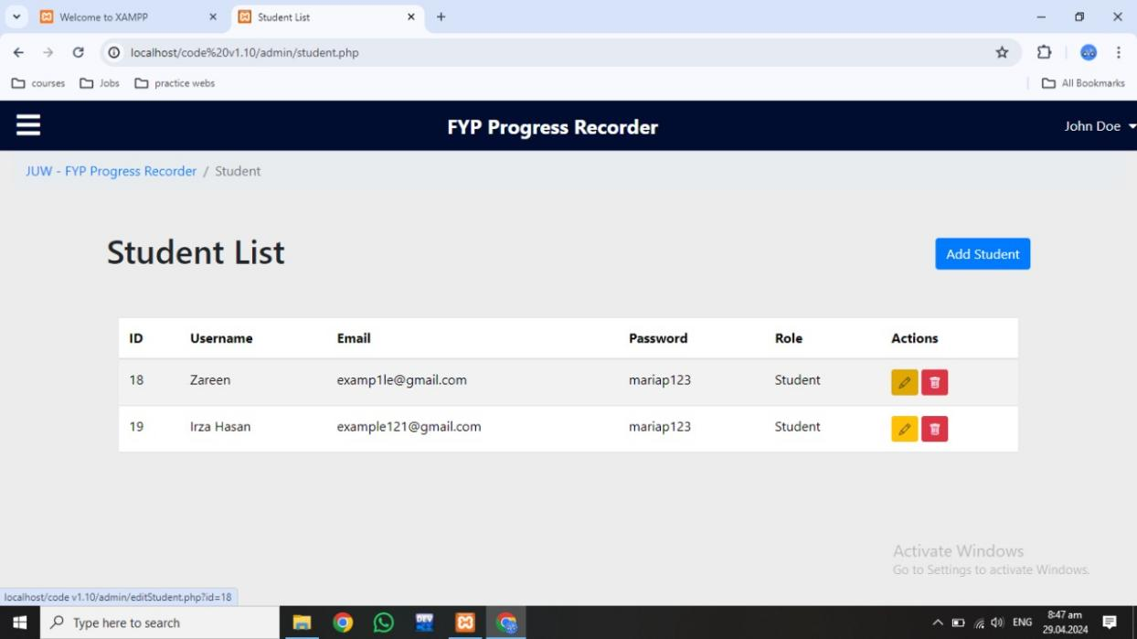

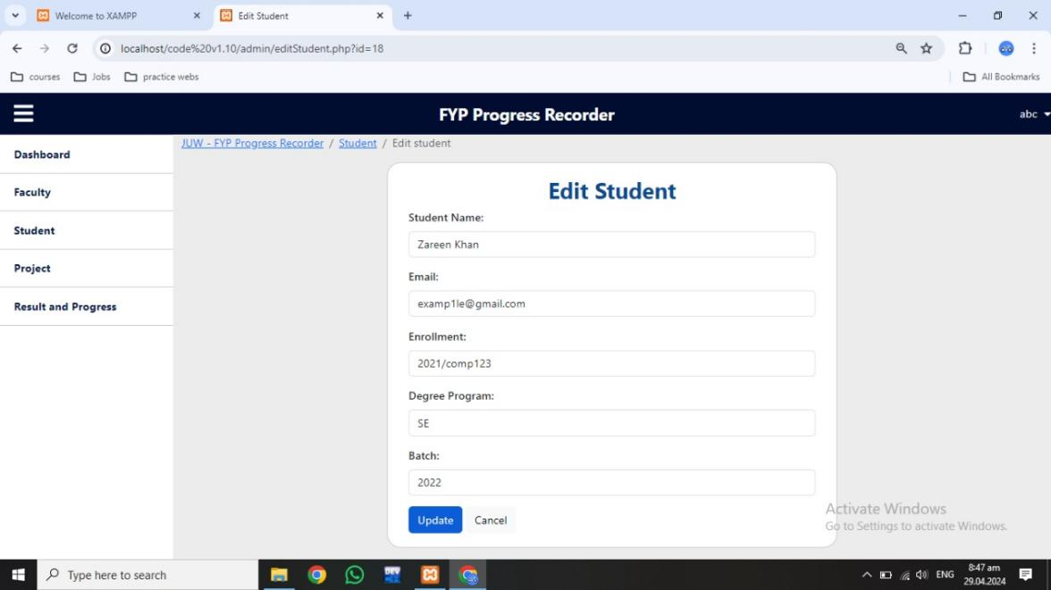

# APPENDIX B

# ABBREVIATION

**Table B.1**: Abbreviations

|  |  |  |
| --- | --- | --- |
| **S. no** | **Abbreviation** | **Full Form** |
| 01 | FYP | Final Year Project |
| 02 | SRS | Software Requirement Specification |
| 03 | ERD | Entity-Relationship Diagram |
| 04 | API | Application Programming Interface |
| 05 | UI | User Interface |
|  |  |  |
|  |  |  |